**RECREATION PREFERENCES FOR THE MAKILING BOTANIC GARDENS OF UNDERGRADUATE UPLB STUDENTS**

**(Thesis)**

**KRIZELLE KAYE M. MANESE**

**SUBMITTED TO THE FACULTY OF THE**

**COLLEGE OF FORESTRY AND NATURAL RESOURCES**

**UNIVERSITY OF THE PHILIPPINES LOS BAÑOS**

**IN PARTIAL FULFILLMENT OF THE**

**REQUIREMENTS FOR THE DEGREE OF**

**BACHELOR OF SCIENCE IN FORESTRY**

**(Production and Industrial Forestry)**

**MAY 2018**

**This thesis manuscript can be accessed:**

|  |  |
| --- | --- |
| **By the general public** | **Yes** |
| **Only after consultation with the author of adviser** | **No** |
| **Only by those students bound by confidentiality agreement** | **No** |

**Signature of Student: ________________**

**Signature of Adviser: ________________**

The thesis attached hereto, entitled **“RECREATION PREFERENCES FOR THE MAKILING BOTANIC GARDENS OF UNDERGRADUATE UPLB STUDENTS,”** prepared and submitted by **KRIZELLE KAYE M. MANESE** in partial fulfillment of the requirements for the degree of **Bachelor of Science in Forestry (Major in Production and Industrial Forestry)** is hereby accepted.

**MARGARET M. CALDERON**

**Adviser**

_______________________  **Date Signed**

Accepted as partial fulfillment of the requirements for the degree of

Bachelor of Science in Forestry.

**MARGARET M. CALDERON**

**Director, Institute of Renewable Natural Resources**

______________________

**Date Signed**

**WILLIE P. ABASOLO**

**Dean, College of Forestry and Natural Resources**

____________________

**Date Signed**

**Biographical Sketch**

The author was born on September 10, 1997 in Sta. Cruz, Laguna. She is the eldest daughter of Maribel M. Manese and Christopher E. Manese. She finished elementary at Makiling School Inc., and high school at the Christian School International. She had been part of different clubs during the high school and a student council for over a year. She is a member of Bukas loob sa Diyos Youth Ministry.

Studying in UP was her dream ever since she was a kid, that is why she was filled with joy when she learned that she was admitted to the University of the Philippines Los Baños (UPLB) for school year 2014-2015. She entered UPLB in 2014 to pursue a degree on Bachelor of Science in Forestry. In 2015, she joined UP VARRONS LTD, her first college organization. In 2016, she decided to specialized Production and Industrial Forestry with focusing on Forest Economics. The University of the Philippines has truly provided her the quality education that an “Iskolar ng Bayan” deserves. UP has taught her how to deal in every challenge in study.

**Acknowledgement**

To **Father in Heaven**, I call upon your Holy Name, and lift you up high to this very moment. You fill me with your grace, love, and mercy each and every day of my life and to you alone do I return all the highest honor and praises. Thank you Father for being the best adviser, best partner, and best friend;

To my adviser, **Dr. Margaret M. Calderon**, thank you for imparting your insights and knowledge, and for sharing your time with my study. Thank you for giving me substantial comments and points to improve my study. I highly appreciate your utmost support to me and this study, thank you very much Ma’am!

To **Professor Canesio Predo**, thank you for sharing your knowledge and time for your valuable suggestions;

To **Dr. Rogelio T. Andrada**, thank you for giving me information about the planned overnight camping at MBG and for accommodating my inquiries;

To **For. Angela Limpiada**, thank you for all the help;

To my batch mates in UP VARRONS LTD, Batch Kalabaw ’15, for the love and support;

To my co-advisee, **Kuya Bryan**, thank you for being a friend and for checking me out every time;

To my constants in college, **Regine, Beanca, Andi, Pau, Ida, Claude, and Karen**, thank you for cheering me up when I am stressed over our acads;

To my cousins (Beybes), **Ate Rai, Razz, Bianca, Yani, and Jelai,** thank you for being my stress-reliever and source of chika;

To my boyfriend, **Yves Sta. Ana**, who stayed no matter how hard it gets. You know how much I appreciate all your time, effort, care, and concern. You have set one of the turning points in my life and today I thank you for being just the way you are. Today marks another success for us and I am happy to celebrate this with you;

To my **Mama, Papa and my sister, Kriza**. Maraming salamat po sa walang sawang pagmamahal, pagsuporta, pagtitiwala, na inyong ibinibigay sa akin. You are my “Kaya mo yan” in a world full of “Ayaw ko na, suko na”. You have and will always be the best family I could ever wish for, no matter how hard things get, no matter how hard life strikes us, no matter how many failures or trials get in our way, I will always love you fam!

**ABSTRACT**

**MANESE, KRIZELLE KAYE M**, College of Forestry and Natural Resources, University of the Philippines Los Baños, MAY 2018. **RECREATION PREFERENCES FOR MAKILING BOTANIC GARDENS OF UNDERGRADUATE UPLB STUDENTS**

Thesis Adviser: Dr. Margaret M. Calderon

The Makiling Botanic Gardens (MBG) allows daytime activities like educational trips, bird watching, hiking, photography sessions and picnics, but the visitation rate remains less than what MBG can accommodate. This study was conducted to explore the recreation preferences of UPLB undergraduate students for outdoor recreation at MBG, and evaluate the potential of overnight camping. A survey was administered to 100 UPLB undergraduate students to describe their preferred nature-based recreation, familiarity with MBG, knowledge on nature-based recreation, and their interest in overnight camping at MBG.

Results show that walking, jogging, and hiking were the top three (3) recreation activities engaged by the students. Most of the respondents were familiar with MBG and nature-based recreation activities. The nature-based recreation activities that respondents were interested in were stargazing, camping and exposure to endemic plants. A logit regression model was developed to estimate the probability of a “yes” response to the question that asked about the respondents’ WTP for overnight camping at MBG. The estimated WTP of the students for overnight camping was P441.64 per person. Two (2) variables that significantly affect WTP are bid amount and number of outdoor activities engaged in.

Since the results show that UPLB students are interested in engaging in overnight camping and have expressed willingness to pay for it, MBG may offer overnight camping and develop facilities for overnight camping at MBG. A feasibility study may be undertaken to evaluate the feasibility of overnight camping from the market, technical, financial, and organizational feasibility aspects.

**Table of contents**

Title page i

Blank (Flyleaf) page ii

Acceptance sheet iii

Biographical sketch iv

Acknowledgment v

Abstract vi

Table of contents vii

List of Appendices/Figures ix

List of Tables x

**CHAPTER I. INTRODUCTION**

Background of the Study 1

Statement of the Problem 4

Objectives of the Study 5

Significance of the Study 6

Scope and Limitations of the Study 6

**CHAPTER II. REVIEW OF RELATED LITERATURE** 7

Recreation 7

Outdoor Recreation 8

Botanic gardens 9

Overnight camping 10

Contingent Valuation Method 12

**CONCEPTUAL FRAMEWORK**  13

**CHAPTER III. METHODOLOGY** 16

Development of the questionnaire 16

Variables studied 17

Pre-testing 17

Final Questionnaire 18

Sampling 18

Survey Implementation 20

Data processing 21

Data Analysis 22

**CHAPTER IV. RESULTS AND DISCUSSION**  24

Recreational activities of UPLB undergraduate students 25

Familiarity on Nature-based Recreation 28

Engagement on Nature-based recreation 30

Recreation activities desired by UPLB undergraduate students 32

Nature-based recreation areas visited 33

Familiarity with the Makiling Botanic Gardens (MBG) 34

Sources of information about MBG 35

Actual visits to MBG 35

Activities in MBG engaged in 36

Desired Nature-based recreation activities in MBG 37

Proportion of Respondents to WTP Question 38

The Logit Regression model 39

Estimation of Mean Willingness to Pay 40

**CHAPTER V. SUMMARY and CONCLUSIONS**  43

**CHAPTER VI. RECOMMENDATIONS** 44

**REFERENCES/LITERATURE CITED** 45

**APPENDICES**  50

**List of Appendices**

Appendix Title Page

A The Makiling Botanic Gardens 50

B Final Survey Questionnaire 52

C Consent Form 59

D Coding guide 60

**List of Figures**

Figure Title Page 1 the Location Map of MBG 1

2 Visitation rate of MBG 5

3 Conceptual Framework 15

4 The researcher conducts personal interview 21

5 Indoor recreation activities of UPLB undergraduate students 28

6 Activities in MBG engaged in by UPLB undergraduate students 37

7 Desired activities of the students inside MBG

8 Proportion of Respondents to WTP 38

**List of Tables**

Tables Title Page

1 Hypothesized effect of the variables to the WTP 14

2 Distribution of survey respondents by college and sex 24

3 Outdoor Activities of UPLB Undergraduate Students 25

4 Knowledge of the students about nature-based recreation 29

5 Students' understanding of nature-based recreation activities 30

6 Engagement of respondents in nature-based recreation 31

7 Frequency of the respondents in engaging Nature-based recreation 31

8 Nature-based recreational that UPLB undergraduate students want to engage in 32

9 Nature-based recreation areas visited by students 33

10 Familiarity with Makiling Botanic Gardens 34

11 Sources of information about Makiling Botanic Gardens 35

12 Number of respondents who visited the Makiling Botanic Gardens (MBG) 36

13 Interest of UPLB undergraduate students on overnight camping in MBG 38

14 The logit regression model 40

15 Mean willingness to pay 41

16 Marginal effect after logit 42

**Chapter I**

**Introduction**

**Background of the Study**

The Makiling Botanic Gardens (MBG) covers an area of 300 hectares in the College of Forestry and Natural Resources (CFNR) and in campus of the University of the Philippines Los Baños. It is situated at approximately 200 meters above sea level (masl). MBG was built in September 1965. It used to be a resort that has a swimming pool and a big cage for birds. However, these facilities have been closed since 2005 because they were too expensive to maintain. In the case of the swimming pool, it could not compete with private resorts that abound in Calamba and Los Baños.

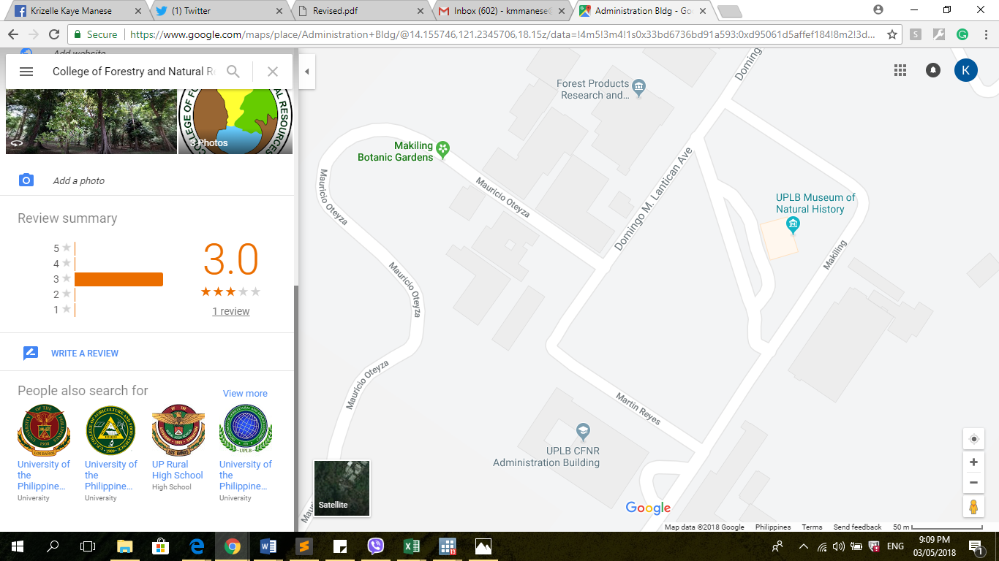

Figure . Location Map of Makiling Botanic Gardens Source: Google Map

Among the points of interest at MBG (Appendix A) are the dipterocarp arboretum, bambusetum, natural forest, a pavilion, and picnic area. The bambusetum hosts a collection of different bamboos. The Makiling Botanic Gardens Natural Forest is the site where endemic trees in the Philippines are found. The Makiling Center for Mountain Ecosystems (MCME) is responsible for the management of the Mount Makiling Forest Reserve (MMFR), of which MBG is a part. The MCME is subdivided into five (5) divisions. The division that is directly responsible for the management of the MBG is the Botanic Gardens, Parks, and Ecotourism Division (BGPED) that is headed by Dr. Rogelio T. Andrada II.

MBG serves as a recreational area to visitors who come for educational trips, tree planting and nurturing and outdoor recreation activities. It hosts several species of flora and fauna that serve as natural attractions that make the botanic gardens economically valuable (Francisco and Espiritu, 1999). It also serves as a venue for weddings, receptions and photo shoots (Bantayan, et al., 2013). The recreation function of MBG is a primary source of revenue, as it charges an entrance fee of Php 20 per visitor. The recreation revenue of MBG is also important to visitors since it provides them satisfaction through their experiences inside the garden. People visit a garden like MBG voluntarily in order to generate satisfaction by the appeal of the natural setting and various plants inside (Kraus, 1978). It also stimulates a person through a sense of accomplishment in doing difficult or tiring activities, or activities that are not done normally. This boosts self-worth and improves the self-image of a person by generating positive feedback in achieving personal goals (Gray and Pelegrino, 1973).

Engaging in outdoor activities can be beneficial to people because they can have positive effects on people’s physical, behavioral, and cognitive characteristics. One of the main outdoor activities that people engage in is outdoor camping. According to Clark, Hendee and Campbell (1971), camping is mostly regarded as an activity that only occurs in isolated places like mountains and grasslands, but camping can also be done in well-organized and camping-oriented places. Camping can promote people’s passion towards the environment and can also provide families and friends a different kind of bonding experience while culturing their inner spirits and self with the surroundings of a camp area.

Camping is an activity that is currently not offered at the Makiling Botanic Gardens but it has the potential to be a great outdoor activity that can showcase the hidden wonders of nature. The MBG is an ideal place where people can relax and engage in nature-based activities. This study thus explores the possibility of offering camping at MBG.

**Statement of the problem**

At present, MBG allows daytime activities like educational trips, bird watching, hiking, photography session and picnic. However, the visitors engaging in these activities are usually walk-in visitors. They are rarely organized events so these activities are not conducted on a regular basis. The inadequate promotion of MBG has resulted in low awareness among people, especially visitors, about MBG and the daytime activities offered. The MBG is promoted on social media through an official website, www.mountmakiling.org, and through word of mouth, which has very limited reach.

The website of MCME provides information about the different points of interest in MMFR, and one these is MBG. Aside from the website, the management of MBG posts the different activities of the garden and the featured for the month in Facebook.

As a result of insufficient promotion efforts, the annual visitation rate has been decreasing since 2012 (Figure 2). With the decreasing number of visitors came the declining revenues from entrance fees, which reduced the funds available for the maintenance of MBG’s facilities. The revenue from the entrance fees goes to the UPLB central administration where the management can request for funds to produce supplies and materials that can be used in the maintenance and management of the garden.

This study explored the potential of MBG to increase its visitation rate and revenue-generating capacity by looking at undergraduate students of the University of the Philippines Los Baños. As of school year 2017-2018, UPLB has 8,570 undergraduate students. Studying the preferences of these students, especially nature-based recreation and camping, can reveal information that can be used to attract them to MBG. The participation of UPLB students in nature-based recreation can provide them beneficial effects such as opportunities to relax and deal with stress from school work.

Figure 2. Visitation Rate of MBG (2008-2016) Source: BGPED

**Objectives**

The study aimed to evaluate the potential of overnight camping at the Makiling Botanic Gardens among undergraduate UPLB students. Specifically, it aimed to:

1. Describe the recreational activities of UPLB undergraduate students;

2. Identify other recreational activities at MBG that college students are interested in;

3. Assess the interest of college students in overnight camping at MBG; and

4. Estimate their willingness to pay for overnight camping.

**Significance of the Study**

The activities currently offered at MBG are limited, and have contributed to low visitation rates and revenue operating capacity. More importantly, the potential of MBG to showcase different recreation activities is not fully realized. Adding new activities in MBG, such as camping, can widen the range of activities available to visitors, enhance the recreation experience of visitors, and increase revenue that can be plowed back to the sustainable management of the gardens. New recreational activities will enhance the appeal of MBG as a botanic park, and increase awareness about the importance of forests and forest conservation among its visitors and the public in general.

**Scope and Limitations**

The study focused on the evaluation of the potential of overnight camping at MBG among UPLB undergraduate students, and their preferences for nature-based recreation. Forleo, Gagliardi and Romagnoli (n.d.) have studied factors of willingness to pay of students where they treated the allowance like income. The study recognizes that some students may not have the capacity to pay because they have no income sources. Due to time and logistical constraints, the sample of the study consisted of 100 respondents who were interviewed over a period of 1 month.

**Chapter II**

**Review of Related Literature**

**Recreation**

Recreation comes from a Latin word *recreare* which means to renew or be refreshed.  It is defined as the use of leisure time that gives a feeling of achievement to the person. It is an emotional condition within a person that comes from a feeling of well-being and satisfaction. Recreation may be considered as an activity of a person during his free time and withdraws a pleasurable and satisfying feeling (McCall and McCall, 1977). Engaging in recreation is becoming a popular activity for the individual who wants to relax and unwind.

Recreation is a form of ecosystem services that provides an important value to people. Recreation usually takes place in wilderness and protected areas (Marion, Leung, and Burroughs, 2016). Burch (1964) suggested concepts and patterns of thinking that may help the recreation manager for the management and protection of the recreation resources. These include considering the recreation behavior of visitors that will allow the manager to plan improvements in the variation of recreational opportunities to be offered. Moreover, Burch wrote that considering the knowledge of the recreationist in the resource system may lessen the problems in managing and enhancing the recreationist’s satisfaction.

Visitor’s satisfaction can help the park as well. Whenever the satisfaction is high, the visitor will have a tendency to go back to the park or recommend the park to a friend. A study conducted by Mutanga et al. (2017) investigated the overall visitor’s satisfaction and experience in two African protected areas. The researchers surveyed 128 respondents in Gonarezhou and Matusadona National Parks, Zimbabwe. The study found that while understanding how to motivate visitors is important, it is also necessary for park planning and management to know the indicators of a good visitor experience. The study recommended the need to consider the tourist heterogeneity and demographic-based needs of the visitor. Knowing the visitor’s characteristics can easily help the recreation manager to know their preferred activities.

Recreational preference is the desire of an individual in doing recreational activities. Boll, Haaren and Ruschowski (2014) explored the recreation preferences of urban dwellers and the relationship between actual use and perceived value of recreation areas in a case study in the Hamburg Metropolitan Region. The research found that perceived naturalness was strongly related to dwellers’ preference. People also looked on the diversity, uniqueness, and naturalness of the landscape to be far more important than the accessibility of the recreation areas and the provision of service facilities. Therefore, visitor’s perception of the values of recreation activities is important for the recreation manager to know the psychological forces and factors that motivate and satisfy the visitor (Chon, 1989).

**Outdoor Recreation**

Outdoor recreation includes activities that an individual does in the woods, parks and even in marine parks (Jenkins and Pigram, 2006). On the other hand, nature-based recreation refers to activities that focus on the elements of nature (Siavanen et al., 2013). These activities include camping, picnicking, rafting, boating, jet skiing, fishing, hunting, horseback riding, running, hiking, canoeing, and other activities that can be done in the wilderness (Manning, Anderson and Pettengill, 2017).

Outdoor recreation activities that children engage in have implication as they move into adulthood. According to Sandoval (2013), people who participated in recreational activities during childhood were most likely to spend more recreational activities when they become adults. Mosonyi, Konyves, Fodor and Muller (2013) examined the leisure activities of 150 college students from Szolnok, Hungary. In the analysis, the frequency relationship of watching TV and doing sports was not significant, while watching TV occasionally and doing recreational activities turned out to be significant. Furthermore, 92% of the students travelled at least once a year and they were conscious about the price. The theory of planned behavior is used by Ajzen and Driver (1992) to predict the recreation intention and behavior of college students. The study found that along with the theory attitude, subjective norms and perceived behavioral controls can predict the intention in engaging in leisure activities.

Engaging in outdoor recreation activities brings positive effects on college students. According to Misra and McKean (2000), outdoor recreation activities together with anxiety reduction and stress management may be an effective strategy in reducing stress for undergraduate students.

**Botanic gardens**

A botanic garden is a garden that collects, cultivates and displays plants with their botanical names. The collection consists of special plants, herbs, and plant from different parts of the world (Collins, n.d.). It is also a place for research and educational purposes. Hohn (2008), considers botanic gardens as a living museum and an institution that educates people about plants. Botanic gardens provide various benefits like education and conservation of plants. For some people, it can also be a place for outdoor recreation. There are some botanic gardens that allow visitor activities, such as hiking, trekking, photography, geocaching, mountain biking and camping (Laurens, 2014).

Botanic gardens invite a wide range of domestic and international visitors together with the regular visitors from the local area. Ward, Parker and Shackleton (2009) assessed the use and the appreciation of botanic gardens as urban green spaces in South Africa. In the said study, the visitors of the six botanical gardens in South Africa that they surveyed were mostly middle to old-aged and well-educated professionals with medium to high incomes. Benfield (2013) reported that visitors in botanic gardens in the United Kingdom were more diverse compared to the US; that most of the visitors were between 40 and 60; and that the employment groups of the visitors were mostly middle management, junior management, and retired people. The author also cited that in the care of Australia Botanic Gardens, 62.7% of the visitors has a degree and only 37.7% were still at school.

Aside from the conservation purpose of botanic gardens, it can also be a place that offers activities like camping and recreational activities. Norfolk Island Botanical Gardens in Southern California, Ho’omaluhia in Hawaii, and Botanic Gardens of Wales offer camping for family and friends (Phillpot, n.d.).

**Overnight camping**

Camping is considered an outdoor activity that can be complemented with extreme activities. Camping is usually undertaken away from home or in an urban area with an equipment like tents or simple buildings (Merriam Webster, 1828). Camping allows the camper satisfaction as he/she experiences and sees the scenery when the tent is opened (Philpott n.d.).

Camping provides positive effects on the campers. Uhls et al. (2014) conducted a study involving 51 preteens who spent five (5) days at an overnight nature camp where TV, PCs and cell phones were not permitted. The results, after five days of camping and no interaction with gadgets, showed that social interaction together with the time away with screen-based media enhanced a preteen's comprehension of nonverbal passionate signs. Dick, Hedrick and Homan (2009) also noted a positive effect of camping, highlighting the impact on the youth through camping experience. The result of the research showed that the youth gained positive characteristics from the experience of the camp in areas of leadership, character development, self-esteem, decision-making skills, independent living skills, and citizenship.

Feelings of attachment to a specific place may affect the relationship between impact and perception. Price, Blacketer and Brownlee (2017) explained the relationship between place attachment and evaluations on recreation-based ecological impacts at campsites in Utah's Wasatch National Forest using normative theory and visual methods. The findings imply that the level of place attachment could have a differential influence on campers’ evaluations of ecological impacts and site conditions.

However, camping may also have negative impacts on the environment. One negative impact is when a campfire releases toxic gas such as carbon monoxide (CO), which can pollute the air. Leaving garbage in the campsite adversely affects the environment. Trampling on the vegetation sometimes leads to exposure of the roots, which can kill the plants (Vo, 2015). The study of Monz and Twardock (2004) assessed the location and extent of visitor use impacts in the Prince William Sound, Alaska, USA in relation to tourism and recreational activities. They concluded that the future impacts made by the visitors can be limited by directing visitors to abundant, highly resistant exposed beach gravel and away from vegetated area that are susceptible to impacts of overnight camping.

**Contingent Valuation Method**

The contingent valuation method (CVM) is a technique that is used by economists to value goods that are not traded in market. The CVM strategy was initially used in the mid-1960s when Davis (1963) utilized polls to assess the advantages of open air diversion in Maine woodlands zone (Knetsch, 1994). The CVM is a survey-based strategy that is oftentimes utilized to set money-related estimates of ecological merchandise and ventures that are not purchased and sold in the commercial center (Carson, 2000). The CVM studies generate information about the expansive state of the willingness-to-pay (WTP) distribution and information on how that dispersion differs with respondent attributes, for example, income, geographic area, and the idea of the utilization of the natural resoruces. The CV surveys are also capable of directly getting a monetary measure of welfare associated with a discrete change in the provision of natural resources, by substituting one good for another or the minimal substitution of various properties of an existing good. The method allows individuals to express their preferences for environmental resources by answering questions on hypothetical choices (Bateman and Turner, 1992).

The dichotomous choice contingent valuation method, both in the single and the double bound formula, has been the most famous procedure among CV researchers due to its simplicity when it comes to data accumulation. The respondent is required to respond yes or no when inquired as to whether she/he will pay a given amount (bid) for the goods (Strazzera, 2003). The CVM park-related research conducted in Costa Rica estimated the mean WTP values for prevention of agriculture conversion of the Monteverde Nature Preserve among 351 residents and foreign guests.. The CVM study was able to show a particular data and detail including contingent scenarios for better protection of natural resources (Shultz, Pinazzo and Cifuentes, 1998). Lee and Han (2002) also used a dichotomous choice contingent valuation method in estimating the use and preservation values of natural and/or cultural resources in (5) distinctive national parks.

There are many works in the literature that used the contingent valuation method. It is widely used by economists because it is the most efficient compared to other methods of valuing environmental goods and services. The CV survey is a more flexible tool than revealed preference methods such as hedonic pricing, averting behavior, and the travel cost method because, in principle, it is conceivable to use it to analyze preferences for provision levels of products that are unique what is currently observed or has been observed in the past (Carson and Czajkowski, 2012). The CVM allows valuation of a wider variety of non-market goods and services than is conceivable with any of the indirect methods (Rahim, 2008).

Despite the advances, flexibility, and usefulness of CV method, it has been strongly criticized. A key weakness of the contingent valuation technique is the inclination that might be presented by people who have thought processes other than guaranteeing the precision of the outcomes (Markgraf, 2018). The embedding effect is another criticism on CVM that was made by Diamond and Hausman (1994). Embedding is a method of differentiating the value of a good, such as protecting an entire mountain region including the lake. Hackett (2001) explains that the embedding effect happens when the WTP response for the particular goods (protecting the lake) are almost equal to the WTP responses for the overall goods (protecting the whole mountain region). Furthermore, another criticism arises, the warm glow criticism happens when one expresses support for good causes than the particular goods that are being evaluated. In protest bids, the individuals may choose to react to a recent environmental condition rather than focus on the specific item under consideration.

**Conceptual Framework**

The factors that can affect an individual’s willingness to pay for overnight camping in the Makiling Botanic Gardens are summarized in Figure 3, which provides the conceptual framework used in this study.

This study offers that an individual’s willingness to pay for overnight camping at MBG is affected by his/her demographic characteristics, familiarity with MBG, knowledge on, and preferences for nature-based recreation. These factors affect the interest of an individual to participate in overnight camping thus affecting his/her willingness to pay. The hypothesized effects of those variables on WTP were summarize in Table 1.

Table 1. The hypothesized effect of the variables on WTP

|  |  |
| --- | --- |
| **Respondents’ Attribute** | **Hypothesized effect on WTP** |
| Socioeconomic Variables |  |
| Sex  Allowance  College | + males ; - females |
| + |
| - |
| NASC subject taken | + |
| Bid level | - |
| Familiarity on MBG | + |
| Preferences on Nature-based Recreation | + |



Figure 3. Individual's willingness to pay framework

**CHAPTER III**

**Methodology**

The Makiling Botanic Gardens (MBG) is a garden located inside the Mt. Makiling Forest Reserve, which provides a place for research and recreational activities. However, the recreational activities available to visitors are limited only to day activities. As a result, the full potential of MBG in providing recreation services is not realized, and affects MBG’s visitation rate and income-generating capacity. The main purpose of the research was to evaluate the potential overnight camping and to analyze the nature-based recreation preferences at the Makiling Botanic Gardens (MBG) among UPLB undergraduate students.

**Development of the questionnaire**

A questionnaires is an instrument used to collect data for evaluation of a research problem. It helps in gathering information on perception, knowledge, behavior, and attitudes of the respondents. The questionnaire for this study was developed to answer:

1. What are the recreational activities that the UPLB undergraduate students engage in?
2. What are the recreational activities that the UPLB undergraduate students are interested in?
3. Are the UPLB undergraduate students interested in overnight camping in MBG
4. Are the UPLB undergraduate students willing to pay for overnight camping in MBG?

**Variables studied**

The variables in this research consisted of demographic characteristics such as age, sex, course, year level, and allowance per month, which was used as determinants in identifying the nature-based recreation preferences and assessing the willingness to pay for overnight camping in MBG of the UPLB undergraduate students. The familiarity with and knowledge of the respondents on nature-based were also assessed. Furthermore, familiarity with MBG, activities they engaged inside MBG, and the activities they want to experience in MBG were also identified. The willingness to pay of UPLB undergraduate students for overnight camping was estimated and the factors that affect their willingness to pay was identified.

**Pre-testing**

A pre-test is important in the conduct of surveys, and the questionnaire developed in this study was pre-tested. Pre-testing is the management of data collection with a small set of respondents. It is an instrument to test the validity and effectiveness of the questionnaire (Bennett, Morrison and Blamey, n.d.). Conducting a pre-test provides confidence to the researcher. For the CV survey, the pre-test provide an avenue to determine the bid amounts that would be used in bidding game in the final CV questionnaire, the bid amounts generated from the pre-test were Php 50, Php 100, Php 150, Php 250, Php 300, and Php 350 per night.

The pre-test was conducted in October 2017. The researcher used an open-ended type of questionnaire administered among 16 UPLB undergraduate students, with two (2) representatives per college. The answers of the respondents in the pre-test questionnaire were used in developing choices for some questions in the more structured final survey questionnaire. The pre-test questionnaire provided an overview of the study and gathered data about demographics of the respondents, knowledge of the respondents to recreation, their recreational activities, their familiarity with MBG and their interest in and willingness to pay for overnight camping.

**Final Questionnaire**

The final questionnaire (Appendix B) was more structured compared to the pre-test questionnaire. Most of the questions in the final questionnaire followed in a multiple choice format, with choices generated from the pre-test. The respondents were asked to put a check on their answers. The questionnaire consisted of four (4) different parts. The first part was about the demographic characteristics of the respondents.The second part asked about the respondents’ knowledge on nature-based recreation and their preferred nature-based recreation activities of the respondents. The third part of the survey was about the familiarity of respondents with MBG. In this section, the respondents were asked about the activities they want to engage inside the garden. In the final section of the questionnaire, the respondents were presented a hypothetical scenario. In this part, the respondents were asked about their interest in overnight camping at MBG. The willingness to pay on overnight camping were also asked in this section. The final bid amounts used in the CV question were simplified into Php 100, Php 200, Php 300, Php 400, and Php 350. The highest bid amounts generated from the pre-test was Php 350. For the, final survey the highest bid amount that was used was Php 500 to choke WTP.

**Sampling**

A request was made to the Office of the Registrar to obtain the complete list of UPLB undergraduate students which was used as the sampling frame of the study. The list of the students provided the total number of respondents in each college in the university.

The sample size that was used in the survey was obtained using Slovin’s Formula:

$$n=\frac{N}{1+{Ne}^{2}}$$

Where:

n = sample size

N= total number of population of undergraduate students in UPLB

e = designated margin of error

The population was composed of 8570 undergraduate students. Using a designated margin of error of 10%, the sample size computed was of 100 UPLB undergraduate students. The sampling method that was used for the implementation of survey was stratified random sampling. Stratified random sampling is a method of sampling that involves division of the population into smaller group which is called strata (Investopedia, 2018). In this method, smaller groups are formed based on members’ similar characteristics. The advantage of using this kind of sampling method is that it produces attributes in the sample that are proportional to the overall population (Investopedia, 2018). The total number of respondents, i.e. 100 respondents, were proportionately distributed among the eight (8) college in the university. The total number of population per college was used as a basis for determining the weight or proportion of respondents per college, or:

$$Proportion of respondents=\frac{Population of students per college }{ Population of students in UPLB}$$

The respondents per college were randomly selected from the complete list of students obtained from the University Registrar. The randomization was executed using the generated random numbers in excel.

**Survey Implementation**

After the sample respondents who would be included in this study was generated, the researcher contacted them on social media, particularly through Facebook. A consent form (Appendix C) was presented and was signed by the respondents. Personal interview was implemented to get a higher response rate and to ensure good understanding of the survey’s objective. The contingent valuation questionnaire was posed using the dichotomous choice format. The advantage of using this kind of format is that it gives a more realistic answer because the respondent makes his/her decision based on the fixed price. In the survey implementation, the distribution of the bid amounts were consecutively assigned to the respondents.

The researcher involved enumerators in the implementation of the survey. The researcher explained the objectives of the study, to the enumerator, discussed the questionnaire and emphasized the importance of requesting respondents to sign the consent form. The researcher made sure that the one who helped in the survey proper understood the questionnaire and the study. Once the survey was completed, the researcher checked the accomplished questionnaires to verify if the respondents answered correctly to the survey questions and the accuracy of the enumerators in conducting the survey.

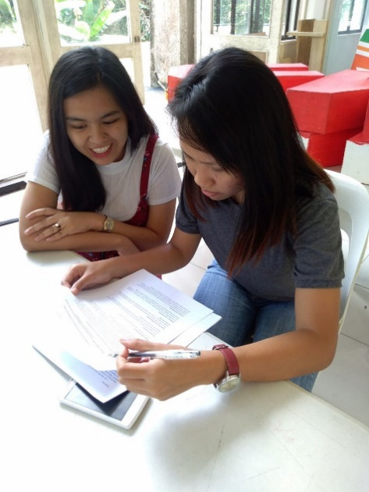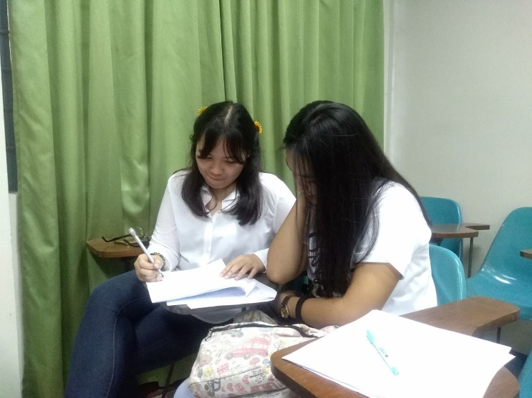

Figure 4. The researcher conducts personal interview with undergraduate UPLB students

**Data processing**

After the implementation of the CV survey, the data gathered were processed and encoded using a spreadsheet. Some of the variables were used as explanatory variables for the logit model used in the study. Demographic data obtained from the respondents such as age, sex, course, year level, allowance per week, and annual family income were used as determinants in assessing the recreational preferences and estimating the willingness to pay of the undergraduate students for overnight camping at Makiling Botanic Gardens (MBG).

The data obtained from the survey results included quantitative and qualitative data. The qualitative data was coded. Coding is the process of sorting and organizing the data. Qualitative data were coded in binomial format to facilitate processing using a statistical software (Appendix D). A dummy variable is a numerical variable that is used in regression analysis to symbolize subgroups of the sample in the study. Dummy variables are frequently used to classify different treatment groups, in this study, the nominal variables. Another advantage of binomial code is that nominal variable can be treated statistically (William, 2006). Some of the variables were grouped according to their relationship. College and the NASC subject they took were grouped according to their relationship with environment.

**Data Analysis**

Frequency distribution was used to describe the respondents’ characteristics, existing activities they engage in, the recreational activities they prefer, and other variables.

[Logistic regression](http://www.statisticssolutions.com/academic-solutions/membership-resources/member-profile/data-analysis-plan-templates/data-analysis-plan-logistic-regression/) is used to find the odds ratio in the presence of more than one explanatory variable (Sperandei, 2014). Logit model is also the analysis to perform when the dependent variable is binary (StatisticsSolution, 2018). In this study, logistic regression model (Equation 1) was developed to describe the relationship between respondents’ willingness to pay (WTP) for overnight camping at MBG and the factors affecting MBG.

$log({\frac{P}{1-P}})=b_{0}+{b_{1}X}_{1}+{b_{2}X}_{2}+{b_{3}X}_{3}+…+{b_{n}X}_{n}$ (Equation 1)

Where:

Log is the odds of estimate

$b_{0}$ is the constant

$b_{1}, b_{2},…,b_{n}$ is the coefficient

$X_{1},X_{2},…, X_{n}$ is the mean

The parameters’ estimates were also generated from the logit regression model in order to calculate the estimated mean willingness of the respondents for the overnight camping at the MBG (Equations 2 and 3). Marginal effects were also calculated to distinguish the effect of the independent variable is the derivative of a given function of the covariates and coefficients of the prior estimation (Boggess, 2018).

Mean WTP= $\left(-\frac{α+ Σ\left(B_{1}{BX}_{1}\right)}{B_{2}}\right)$ $(Equation 2)$

Where:

$α$ is the constant coefficient

B is the coefficient of the variables

X is the mean of the variables

$$Mean WTP{= -\frac{(α + {β_{sex}X}_{sex}+{β_{college}X}_{college}+{β_{envinasc}X}_{envinasc}+…+{β_{n}X}_{n})}{βbidlevel} } (Equation 3)$$

Where:

$α$ is the constant coefficient

$β_{x}$ is the coefficient of the variables used

$X_{x}$ is the mean of the variables used

The variables used in the logit model analysis were only those that may be relevant to the WTP of the respondents. These variables include sex, college that are highly related with environment, NASC subjects that they took which was environment-themed, their outdoor activities, bid level, and their visitation in MBG.

**CHAPTER IV**

**Results and Discussion**

A contingent valuation survey involves 100 UPLB undergraduate students was conducted to evaluate the potential of overnight camping at the Makiling Botanic Gardens. The respondents were selected using stratified random sampling, which generated 60 female respondents (60%) and 40 male respondents (40%). Being the biggest college, in terms of students’ population among the eight (8) colleges of UPLB, College of Arts and Sciences (CAS) had the highest wave of respondents in the survey with 27 respondents followed by College of Engineering and Agroindustrial Technology (CEAT) with 23 respondents (Table 2). The College of Development Communication had the lowest number of respondents at five (5). Since the respondents were all college students, their ages ranged from 18-24 years old.

Table 2.Distribution of survey respondents by college and sex

|  |  |  |  |
| --- | --- | --- | --- |
| **College** | **No. of Respondents** | | |
| **Female** | **Male** | **Total** |
| CAFS | 8 | 4 | 12 |
| CAS | 18 | 9 | 27 |
| CDC | 4 | 1 | 5 |
| CEAT | 8 | 15 | 23 |
| CEM | 6 | 4 | 10 |
| CFNR | 4 | 4 | 8 |
| CHE | 7 | 1 | 8 |
| CVM | 5 | 2 | 7 |
| **Total** | **60** | **40** | **100** |

**Recreational activities of UPLB undergraduate students**

Table 3 shows the recreational activities that undergraduate students engaged in. These include jogging, cycling, swimming, picnic, walking, hiking, camping, and sports activity. The respondents were allowed to give multiple answers. The results show that out of 100 respondents, 87 respondents were into active walking. Respondents from CAS had the highest number of students engaging in walking while respondents from CDC had the lowest engagement in walking. There were 59 respondents who were interested in jogging. CEAT and CAS has the highest number of respondents involved jogging, where CHE had the lowest number of respondents who were into jogging. In addition, 43 students preferred sports for recreation, with CEAT having the more respondents who were into sports and CDC with the lowest. There were 42 respondents who indicated hiking as their recreation activity. Again, CEAT had the highest number of students that were into hiking and CHE had the least respondents. Moreover, 35 respondents were engaged in swimming, with CAS having the highest number of respondents.

There were 25 respondents who were into camping. CAS had the highest number of students who have experienced camping while CHE had the least number of respondents engaged in this kind of activity.   Furthermore, only 15 students were engaged in zip lining and the highest number of respondents who indicated this kind of activity were from CAS. Out of all the outdoor activities participated by the respondents, the top three (3) were walking, jogging, and hiking.

Walking as the most preferred recreational activity of the respondents can be attributed to their means of mobility in the university. Additionally, jogging was the second activity that most of the respondents were fond of doing. This finding implies that the proximity of the field in the university make it easier for the respondents to walk or jog. Hiking was the third activity that the respondents has as a recreational activity, which can be attributed to the nearness of the Mt. Makiling Forest Reserve, a popular area among hikers. It can be inferred that being involved in these activities is a way by which the respondents cope up with the academic stress in the university. According to Misra and McKean (2000) leisure activities can help in reducing the stress of college students. Mitchel (2012) found that physical activity in a natural environment is related to a decrease in the risk of poor emotional well-being to a greater extent than physical activities in different conditions.

|  |  |  |  |  |  |  |  |  |
| --- | --- | --- | --- | --- | --- | --- | --- | --- |
| **College** | **Walking** | **Jogging** | **Sports activity** | **Hiking** | **Swimming** | **Camping** | **Zip- lining** | **Total** |
| CAFS | 11 | 8 | 4 | 4 | 2 | 3 | 0 | 32 |
| CAS | 23 | 16 | 11 | 11 | 10 | 9 | 7 | 87 |
| CDC | 4 | 3 | 1 | 2 | 1 | 1 | 1 | 13 |
| CEAT | 20 | 16 | 12 | 15 | 8 | 7 | 4 | 82 |
| CEM | 8 | 6 | 6 | 5 | 5 | 2 | 1 | 33 |
| CFNR | 8 | 5 | 3 | 4 | 2 | 1 | 0 | 23 |
| CHE | 7 | 2 | 1 | 0 | 4 | 0 | 0 | 14 |
| CVM | 6 | 3 | 5 | 1 | 3 | 2 | 2 | 22 |
| **Total** | **87** | **59** | **43** | **42** | **35** | **25** | **15** | **306** |

Table 3. Outdoor Activities of UPLB Undergraduate Students

*Multiple answers allowed

Figure 5 presents the indoor recreation activities that the respondents engage in. Surfing the internet, watching movie or television, writing, and reading were the indoor activities that were commonly undertaken by the respondents. Out of 100 respondents, 93 respondents chose to surf the internet as their recreational activity, the CAS and CEAT having the highest number of respondents and CDC have the lowest. There were 89 who watched television, for recreation, with CAS having the highest number and CEM having the lowest. There were 78 respondents who preferred reading books as their recreational activities with the highest from CAS and the lowest from CFNR. A total of 54 students chose playing video games as their usual activity with CEAT having the more respondents and CDC having the least. There were 42 students who were into writing for recreation, with CAS having the highest count of respondents, CFNR and CHE indicated interest in writing as a recreational activity. Furthermore, only two (2) students from CEAT and CEM were into dancing, one (1) student from CEM was interested arts activity, and one (1) student from CAS indicated listening to music. There was one from CVM who indicated sleep as a recreation activity. However sleep is not a recreational activity since it is a basic need of a human being (AlternativeCure, 2011).

The top three (3) indoor activities that the respondents engaged in were surfing the internet, watching TV/movie, and playing video games. Surfing the internet is used for socializing that can be considered a recreational activity of the respondents. Some of the respondents may be away from their home and use the internet, particularly Facebook, to connect with their family. Ellison, Steinfield and Lampe (2007) explains the relationship of the famous social networking site with college students, as Facebook helps a person to stay connected with the family members. It can boost the morale of a person with low self-esteem and life satisfaction. Surfing the internet may also be done for academic purposes of the respondents. According to Clarke et al. (2002), the internet is a great tool for college students to interact and to get information for their studies. Their study found that 79% of college students consider the internet to have a positive impact on their academic experience. Playing video games and watching television or movie may be also a way of the students to cope up with the academic stress in the university. Reinecke (2009) associated work and game use. People with emotion-focused coping style have a higher tendency to use games for recovery than those with problem-focused coping style.

Figure 5.Indoor recreation activities of UPLB undergraduate students

*Multiple answers allowed

**Familiarity on Nature-based Recreation**

Recreation is considered as an activity of a person during his free time and withdraws a pleasurable and satisfying feeling (McCall and McCall, 1977). Nature-based recreation involves activities that rely on natural environment setting and affect the one’s well-being and can provide a feeling of satisfaction (Carter, 2009). As shown in Table 4, 65 of the respondents have knowledge on nature-based recreation. All of the respondents from CFNR were more familiar with the nature-based recreation compared to respondents from other colleges. This may be due to CFNR respondents’ greater exposure to nature-based recreation because of their curriculum. On the other hand, there were 35 respondents who were unfamiliar with nature-based recreation, which may have hindered them from engaging in nature-based recreation.

Table 4. Knowledge of the students about nature-based recreation

|  |  |  |  |
| --- | --- | --- | --- |
| **College** | **Familiarity with Nature-based Recreation** | | **Total** |
| **Yes** | **No** |
| CAFS | 2 | 10 | 12 |
| CAS | 13 | 14 | 27 |
| CDC | 2 | 3 | 5 |
| CEAT | 5 | 18 | 23 |
| CEM | 4 | 6 | 10 |
| CFNR | 0 | 8 | 8 |
| CHE | 5 | 3 | 8 |
| CVM | 4 | 3 | 7 |
| **Total** | **35** | **65** | **100** |

The students who stated that they were familiar with nature-based recreation were asked to indicate their understanding of it (Table 5). Out of the 65 respondents who were familiar in nature-based recreation, 45 respondents considered nature-based activities as an activity that focuses on the natural environment. Only 16 of the respondents knew that attitude, behavior and perception could be affected by engaging in nature-based recreational activities. The respondents were more familiar with the idea that nature-based recreation can provide a feeling of satisfaction.

*Table 5. Students' understanding of nature-based recreation activities*

|  |  |  |  |  |
| --- | --- | --- | --- | --- |
| **College** | **Focuses on natural environment** | **Affects the behavior, perception and attitude of a person** | **Provides a feeling of satisfaction** | **Total** |
| CAFS | 8 | 5 | 10 | 23 |
| CAS | 8 | 1 | 10 | 19 |
| CDC | 2 | 2 | 3 | 7 |
| CEAT | 17 | 5 | 22 | 44 |
| CEM | 2 | 1 | 5 | 8 |
| CFNR | 5 | 1 | 6 | 12 |
| CHE | 1 | 1 | 3 | 5 |
| CVM | 2 | 0 | 1 | 3 |
| **Total** | **45** | **16** | **60** | **121** |

*Multiple answers allowed

**Engagement in Nature-based recreation**

Table 6 shows the number of the respondents per college who engaged in nature-based recreation activities. Of the 65 respondents who said that they were familiar with nature-based recreation, only 42 respondents have actually engaged in nature based recreation activities while 23 respondents have not. The result implies that familiarity with the nature-based recreation influences participation in nature-based recreation. The higher is the awareness about nature-based recreation, the more curious people can be, the more chance that they will engage in recreation activities (Milman and Pizman, 2009).

Table 6. Engagement of respondents in nature-based recreation

|  |  |  |  |
| --- | --- | --- | --- |
| **College** | **Engagement in Nature-based Recreation** | | **Total** |
| **Yes** | **No** |
| CAFS | 6 | 4 | 10 |
| CAS | 10 | 4 | 14 |
| CDC | 2 | 1 | 3 |
| CEAT | 12 | 6 | 18 |
| CEM | 3 | 3 | 6 |
| CFNR | 5 | 3 | 8 |
| CHE | 1 | 2 | 3 |
| CVM | 3 | 0 | 3 |
| **Total** | **42** | **23** | **65** |

The respondents who participated in nature-based recreation were asked about the frequency of their activities. As shown in table 7, 28 of the respondents engaged in nature-based recreation activities monthly which implies a higher possibility of engaging in overnight camping in MBG.

Table 7. Frequency of the respondents in engaging Nature-based recreation

|  |  |  |  |  |  |
| --- | --- | --- | --- | --- | --- |
| **College** | **Monthly** | **Occasionally** | **Weekly** | **Yearly** | **Total** |
| CAFS | 5 | 0 | 1 | 0 | 6 |
| CAS | 5 | 3 | 0 | 1 | 9 |
| CDC | 2 | 0 | 0 | 0 | 2 |
| CEAT | 6 | 4 | 2 | 0 | 12 |
| CEM | 3 | 0 | 1 | 0 | 4 |
| CFNR | 5 | 1 | 2 | 0 | 8 |
| CHE | 1 | 0 | 0 | 0 | 1 |
| CVM | 1 | 0 | 2 | 0 | 3 |
| **Total** | **28** | **8** | **8** | **1** | **45** |

**Recreation activities desired by UPLB undergraduate students**

The respondents were asked about the activities that they wanted to engage in. Out of 100, 72 respondents chose hiking as the nature-based recreation that they were interested in, followed by camping (70 respondents) and picnic (57 respondents). Hiking and picnic are currently available at MBG while camping which was the second most desired is the focus of the study. This implies that respondents can participate more in recreation activities available at MBG because of their proximity. This also implies that undergraduate UPLB students are a potential market for MBG.

Recreational activities at MBG may be developed to offer students a break from academics, develop appreciation for nature, and improve their socialization. Outdoor activities promote for socialization since most outdoor activities need a partner or companion. Results suggest that the straightforwardness and simplicity of acknowledging nature and its excellence, through wildlife viewing, seeing vegetation, sitting by or simply appreciating a beautiful scenery, can regularly be an action in itself (Barness, 2009).

Table 8. Nature-based recreational that UPLB undergraduate students want to engage in

|  |  |  |  |  |
| --- | --- | --- | --- | --- |
| **College** | **Hiking** | **Camping** | **Picnic** | **Total** |
| CAFS | 9 | 11 | 9 | 29 |
| CAS | 19 | 16 | 15 | 50 |
| CDC | 5 | 4 | 3 | 12 |
| CEAT | 18 | 17 | 12 | 47 |
| CEM | 6 | 5 | 6 | 17 |
| CFNR | 5 | 6 | 3 | 14 |
| CHE | 6 | 6 | 7 | 19 |
| CVM | 4 | 5 | 2 | 11 |
| **Total** | **72** | **70** | **57** | **199** |

*Multiple answers allowed

**Nature-based recreation areas visited**

The students were asked about the nature-based recreation areas they have visited. As shown in Table 9, the most visited recreation area of the respondents was park (96 respondents). Moreover, followed by beach (94 respondents), and zoo (84 respondents). The results show that respondents prefer easily accessible places and those that are popular among other people. Barness (2009) explains that most people engage in outdoor recreational activities in areas that are easily accessible to their home in terms of transportation and proximity.

Table 9.Nature-based recreation areas visited by students

|  |  |  |  |  |  |  |
| --- | --- | --- | --- | --- | --- | --- |
| **College** | **Parks** | **Beach** | **Zoo** | **Forests** | **Mountains** | **Campsites** |
| CAFS | 12 | 9 | 10 | 9 | 8 | 9 |
| CAS | 27 | 26 | 24 | 21 | 21 | 17 |
| CDC | 4 | 5 | 4 | 3 | 4 | 4 |
| CEAT | 23 | 22 | 19 | 18 | 17 | 12 |
| CEM | 9 | 10 | 8 | 7 | 7 | 4 |
| CFNR | 8 | 8 | 7 | 8 | 8 | 5 |
| CHE | 8 | 8 | 7 | 4 | 6 | 3 |
| CVM | 5 | 6 | 5 | 5 | 4 | 6 |
| **Total** | **96** | **94** | **84** | **75** | **75** | **60** |

*Multiple answers allowed

**Familiarity with the Makiling Botanic Gardens (MBG)**

Table 10 shows that out of 100 respondents, 93 were familiar to MBG. The 7 respondents who were not familiar from CEAT (6 respondents) and from CAS (1 respondent). The high level of familiarity with MBG among respondents can be used to encourage greater visitation to and participate in the activities inside MBG. Hammit (2009) found that, preferences for an area may increase after visiting a place, and prior visit to the place can increase preferences since they are already familiar with it.

Table 10. Familiarity with Makiling Botanic Gardens

|  |  |  |  |
| --- | --- | --- | --- |
| **College** | **Familiarity on MBG** | | **Total** |
| **Yes** | **No** |
| CAFS | 12 | 0 | 12 |
| CAS | 26 | 1 | 27 |
| CDC | 5 | 0 | 5 |
| CEAT | 17 | 6 | 23 |
| CEM | 10 | 0 | 10 |
| CFNR | 8 | 0 | 8 |
| CHE | 8 | 0 | 8 |
| CVM | 7 | 0 | 7 |
| **Total** | **93** | **7** | **100** |

**Sources of information about MBG**

The respondents who were familiar with MBG were asked about their sources of information. As shown in Table 11, the respondents’ information about MBG mainly came from friends and family, subjects they took at UPLB, and from the field trips they had. The result implies that most of the sources of information about MBG came from word of mouth. Only nine (9) respondents learned about MBG from social media.

Table 11. Sources of information about Makiling Botanic Gardens

|  |  |  |  |  |  |  |  |  |
| --- | --- | --- | --- | --- | --- | --- | --- | --- |
| **College** | **Subjects** | **friends and family** | **field trips** | **Local Los Banos residents** | **Social Media** | **Organizations** | **Dorm** | **Total** |
| CAFS | 6 | 8 | 4 | 7 | 0 | 1 | 0 | 26 |
| CAS | 12 | 12 | 8 | 7 | 3 | 0 | 1 | 43 |
| CDC | 5 | 3 | 0 | 0 | 0 | 0 | 0 | 8 |
| CEAT | 7 | 6 | 8 | 7 | 1 | 0 | 0 | 29 |
| CEM | 4 | 6 | 5 | 6 | 1 | 0 | 0 | 22 |
| CFNR | 4 | 6 | 5 | 4 | 1 | 0 | 0 | 20 |
| CHE | 5 | 2 | 4 | 0 | 2 | 0 | 0 | 13 |
| CVM | 1 | 3 | 1 | 3 | 1 | 0 | 0 | 9 |
| **Total** | **44** | **46** | **35** | **34** | **9** | **1** | **1** | **170** |

**Actual visits to MBG**

Table 12 shows that out of 100 respondents, 74 respondents have visited MBG, and 26 respondents have not. As expected, all respondents from CFNR have visited MBG since they use it often for educational purposes. The result suggest that awareness about the place does not necessarily translate to a desire to visit the place. The 26 respondents who have not visited the MBG may have not received information about it, or may have heard negative reviews from others. Millman and Pizam (1995) explain that people who have knowledge about the place but opt not to visit the place may have heard some negative observations from other people and lose interest in visiting the place.

Table 12. Number of respondents who visited the Makiling Botanic Gardens (MBG)

|  |  |  |  |
| --- | --- | --- | --- |
| **College** | **Visited MBG** | | **Total** |
| **Yes** | **No** |
| CAFS | 8 | 4 | 12 |
| CAS | 21 | 6 | 27 |
| CDC | 4 | 1 | 5 |
| CEAT | 16 | 7 | 23 |
| CEM | 6 | 4 | 10 |
| CFNR | 8 | 0 | 8 |
| CHE | 7 | 1 | 8 |
| CVM | 4 | 3 | 7 |
| **Total** | **74** | **26** | **100** |

**Activities in MBG engaged in**

For students who have visited MBG, garden tour was the activity that most of the respondents were familiar with and were able to participate. As shown in figure 6, the respondents also engaged in trekking and bird watching. The results are consisted with the researcher’s expectation because these are the usual activities observed inside the garden. The knowledge of some students about the activities that can be undertaken in MBG can be attributed to the subjects they took in the university, some of which required visit to the MBG.

Figure 6. Activities in MBG engaged in by UPLB undergraduate students

**Desired Nature-based recreation activities in MBG**

Figure 7 shows the activities in MBG that the respondents are interested in. There were 72 respondents who want to experience star gazing, followed by overnight camping (63 respondents. Since there are several endemic plants inside MBG, most of the respondents were also interested in activities that would exposed them to endemic plants.

Figure 7. Desired Activities of UPLB students inside MBG

**Interest in overnight camping**

As shown in Table 13, 86 respondents indicated interest in overnight camping in MBG. There were more female respondents who were interested in participating. The results invalidated the research hypothesis that more male students would like to participate in overnight camping. The highest proportion of female and male respondents came from CAS (13 respondents) and CEAT (13 respondents), respectively. All of the respondents from CFNR were interested in overnight camping. This can be attributed to their exposure to MBG. There were 14 respondents who were not interested in overnight camping, these may be students who are not the outdoor-type of person, afraid of wildlife, prefer activities other than camping, prefer camping in other place like beach, or do not want extreme activities. Moreover, there may be respondents who does not want the idea of using the MBG as it may affect ecological balance in MBG.

Table 13. Interest of UPLB undergraduate students on overnight camping in MBG

|  |  |  |  |  |  |
| --- | --- | --- | --- | --- | --- |
| College | Female | | Male | | Total |
| Yes | No | Yes | No |
| CAFS | 5 | 3 | 3 | 1 | 12 |
| CAS | 13 | 5 | 8 | 1 | 27 |
| CDC | 4 | 0 | 1 | 0 | 5 |
| CEAT | 8 | 0 | 13 | 2 | 23 |
| CEM | 5 | 1 | 4 | 0 | 10 |
| CFNR | 4 | 0 | 4 | 0 | 8 |
| CHE | 6 | 1 | 1 | 0 | 8 |
| CVM | 5 | 0 | 2 | 0 | 7 |
| Total | 50 | 10 | 36 | 4 | 100 |

**Proportion of Respondents to the WTP Question**

The WTP question posed to the respondents was: “Are you willing to pay ____P/night for overnight camping at MBG?”

Of all 86 respondents who were presented the WTP question, 67 respondents said “yes” at various bid amounts (Figure 8). As expected, the lowest bid amount (Php 100) had the highest number of yes response, while the highest bid amount (Php 500) had the lowest response.

Figure 8. Proportion of Respondents to the WTP Question

**The Logit Regression model**

Table 14 shows the logit model developed by the researcher using the data from contingent valuation survey. Logistic regression model (or logit model) was used to identify the factors that significantly affect the dependent variable.

The dependent variable was the probability that students will say “yes” to the WTP question. On the other hand, the independent variables were originally age, sex, course, year level, allowance per week, and annual family income. However, the number of independent variables were too many, which made the model insignificant. Only the data from 86 respondents who were interested in engaging in overnight camping at MBG were used in developing the logit model. Since the total 100 respondents have missing data, 12 observations were dropped. The pseudo R was also computed, which explains the percentage (%) of variability on the response data around its mean. The model have a pseudo-R of 0.1399, which means that the model only explains 14% of the variation in the dataset. The remaining 86% may be accounted by other factors that were not in the model. The low value of pseudo-R can be attributed to the small sample size used in the model.

Out of the seven (7) independent variables included in the model, only two (2) factors were significant at the P Value of 0.05 are their bid level and engagement in outdoor activities. Variables like college, sex, Natural Science subjects, allowance per month, and visitation in MBG were significant at P Value of 0.05.

The bid amount was significant at 5%. The coefficient of -0.0053211, implies an inverse relationship between bid amount and the probability of saying yes to the WTP question. This was consisted with the hypothesis of the researcher that as the bid amount increases, the probability of willingness to pay decreases. The result implies that the respondents were less likely to pay as the bid amount increases. In other words, the probability of being willing to pay was higher for a lower bid amounts. The other factor that was significant at 5% was outdoor activities engaged in by the respondents. The computed coefficient is 0.285127, showing a positive relationship with the probability of being willing to pay. The result implies that the more outdoor activities, respondents are engaged in, the higher the probability of being willing to pay in overnight camping at MBG.

Table 14. The logit regression model

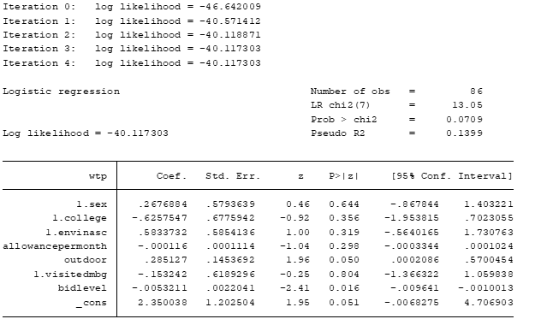

**Estimation of Mean Willingness to Pay**

The mean willingness to pay for overnight camping at MBG was computed using nonlinear comparison of estimators. This allows to estimate one or more linear or nonlinear combinations of parameters from any mode that can be considered as the model parameters. Nonlinear comparison of estimators can be used even if the other predictors were not significant to the P value. As shown in Table 15, the computed coefficient represents the mean WTP (amount) when all predictors were included. On the average, the willingness to pay of an individual is at Php 539. However, the amount computed was outside the highest bid amount of 500. The distribution appears to display a fat-tail problem, which is due to the high number of respondents who said yes to the WTP question even at the highest bid amount of Php 500. Haltia et al. (2006) explain that a fat-tail problem occurs when the bid amounts are grouped around the higher end of the distribution that causes mean WTP to be overestimated. If only the bid amount is used as predictor, the mean willingness to pay was computed to be at Php 441.64.

Table 15. Mean willingness to pay

|  |  |  |  |  |  |  |
| --- | --- | --- | --- | --- | --- | --- |
| **WTP** | **Coef.** | **Std. Err.** | **z** | **P>z** | **[95% Conf.**  **Interval]** | |
| WTP (with all the variables) | 539.6184 | 108.2863 | 4.98 | 0 | 327.3811 | 751.8558 |
| WTP (with Bid amount only) | 441.6417 | 184.6858 | 2.39 | 0.017 | 79.66412 | 803.6193 |

Table 16 shows the marginal effect of the independent variables. Marginal effect is the measures of the rapid change in the dependent variable as the independent variable changes. It is used to explain the effect of the regressors on the dependent variable. The predicted probability of success (P= (yes)) for sex is 4.17% greater for female than male. This imply that having the other variables constant, there is a higher probability of willingness to pay for female than men. Moreover, the predicted probability of success (P= (yes)) is 10.52% lesser for colleges that were highly related on environment than colleges that were not highly related on environment. This imply that college that were highly related on environment has a lesser probability of paying for overnight camping. Furthermore, the predicted probability of success (P= (yes)) is 9.07% greater for  NASC subjects which focus more on environment than NASC subject which were not focusing on environment. Taking a NASC that were highly related on environment gives a greater probability to the respondents to pay for the overnight camping.

The predicted probability of success (P= (yes)) is 2.3% lesser for respondents who visited MBG than to the respondents who were not able to visit in MBG. Letting other things constant, there is a higher probability of paying for those who were not able to visit MBG than those who visited it. The predicted probability of success (P= (yes)) for 1 peso change in allowance will decrease by 0.01%. Holding other variables constant, the probability of willingness to pay would change if the allowance decreases. In addition, The predicted probability of success (P= (yes)) for a change in outdoor activity will increase by 4.38%. There is a higher probability of paying if the respondents were participating in outdoor activities. Lastly, the predicted probability of success (P= (yes)) for a level change in bid activity will decrease by 0.08%. Ceteris paribus, for every increase of bid level, the probability of paying for the overnight camping decreases.

*Table 16. Marginal effects of independent variables*

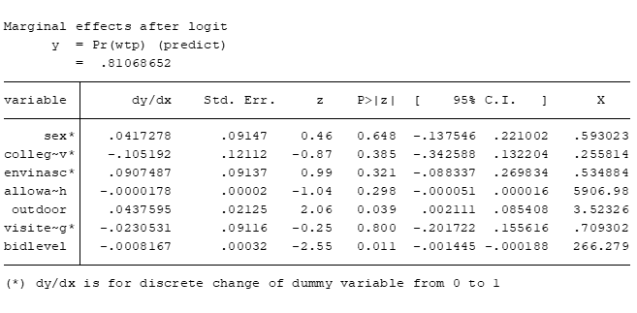

**CHAPTER V**

**Summary and Conclusion**

The purpose of the study was to evaluate the potential of overnight camping at the Makiling Botanic Gardens among undergraduate UPLB students. It specifically aimed to describe the recreational activities of UPLB undergraduate students, identify other recreational activities at MBG that college students are interested in, assess the interest of college students in overnight camping at MBG, and estimate their willingness to pay for overnight camping.

The contingent valuation method (CVM) was used in the study. A survey was undertaken involving 100 respondents selected through stratified random sampling, with the list of UPLB undergraduate students enrolled during the first semester of 2017-2018 as sampling frame. The survey gathered information about the respondents’ socio-economic characteristics, familiarity with MBG, and knowledge on and preferences for nature-based recreation. A logit regression model was developed to estimate the probability of a “yes” response to the question that asked about the respondents’ WTP for overnight camping at MBG, and the WTP was estimated.

Results show that walking, jogging, and hiking were the top three (3) recreation activities engaged by the students. Most of the respondents were familiar with MBG and nature-based recreation activities. The nature-based recreation activities that respondents were interested in were stargazing, camping and exposure to endemic plants. A logit regression model was developed to estimate the probability of a “yes” response to the question that asked about the respondents’ WTP for overnight camping at MBG. The estimated WTP of the students for overnight camping was P441.64 per person, and bid amount was found significantly affect WTP.

**Recommendations**

The study found that the respondents knew about MBG mainly through word of mouth. Management may consider boosting the promotion of MBG using social media more strategically.

Since the results show that UPLB students are interested in engaging in overnight camping and have expressed willingness to pay for it, MBG may offer overnight camping and develop facilities for overnight camping at MBG. There were respondents who said yes to the WTP question even at the highest bid amount of Php 500. It can be used by the management as basis for setting the entrance fee, but the amount may be further validated especially for other user groups.

A feasibility study may be undertaken to evaluate the feasibility of overnight camping from the market, technical, financial, and organizational feasibility aspects.

**Literature Cited**

[Ajzen, I](https://search.proquest.com/indexinglinkhandler/sng/au/Ajzen,+Icek/$N) and Driver, B. (1992). [***Journal of Leisure Research***](https://search.proquest.com/pubidlinkhandler/sng/pubtitle/Journal+of+Leisure+Research/$N/1816610/OpenView/1308690816/$B/61D6DC92BFF34430PQ/1)**; Arlington, Va., etc.**[Vol. 24, Iss. 3,](https://search.proquest.com/indexingvolumeissuelinkhandler/1816610/Journal+of+Leisure+Research/01992Y01Y01$23Jan+1,+1992$3b++Vol.+24+$283$29/24/3) (Jan 1, 1992): 207.

AlternativeCure. (2018). *The Importance of Rest and Recreation*. Retrieved May 2, 2018 from: http://the-alternative-cure.org/health-articles/rest-and-recreation/

Barness, B. (2009). *Nature based outdoor recreation demand and preferences – Qualitative research findings*. Prepared for Parks and Wildlife Group, NSW Department of Environment and Climate Change.

## Bateman, J. and Turner, R. (1992). *Evaluation of the Environment: The Contingent Valuation Method*. CSERGE Working Paper GEC 92-18

Benfield, R. (2013), Garden Tourism, CABI, Wallingford.

Boll, Haaren and Ruschowski (2014). *The Preference and Actual Use of Different Types of Rural Recreation Areas by Urban Dwellers—The Hamburg Case Study*. Published: October 14, 2014. <https://doi.org/10.1371/journal.pone.0108638>

Boyle, K. (n.d.) *Dichotomous-Choice, ContingentValuation Questions: Functional Form Is Important.*

## Brownlee M., Blacketer, M. and Price, S. (2018). *The influence of place attachment on campers’ evaluations of ecological impacts due to recreation use.* [*Journal of Outdoor Recreation and Tourism*](https://www.sciencedirect.com/science/journal/22130780). [Volume 21](https://www.sciencedirect.com/science/journal/22130780/21/supp/C), March 2018, Pages 30-38

[Burch, W. R.](http://www.ingentaconnect.com/search;jsessionid=1r83ma9j7l5pt.x-ic-live-02?option2=author&value2=Burch,%20William%20R.) (1964). *Two Concepts for Guiding Recreation Management Decisions***.** [Journal of Forestry](http://www.ingentaconnect.com/content/saf/jof;jsessionid=1r83ma9j7l5pt.x-ic-live-02), Volume 62, Number 10, 1 October 1964, pp. 707-712(6)

Campbell, F, Clark, R and Hendee, J. (1971). *Journal of Leisure Research*. p. 143

Carson, R. T. (2000), “Contingent Valuation: a User’s Guide.” Environmental Science & Technology, 34, pp. 1413-1418.

Carson, R. and Czajkowski, M. (2012). *The Discrete Choice Experiment Approach to Environmental Contingent Valuation*. University of South Australia.

Chon, K. (1989). *Understanding recreational traveler's motivation, attitude and satisfaction.* Tourism Review 44(1):3-7. DOI: 10.1108/eb058009

Clawson, M. and Knetsch, J. (1966). *Economics for Outdoor Recreation*. The Johns Hopkins University Press for Resources of the Future.

Diamond, Peter A., and Jerry A. Hausman. 1994. "Contingent Valuation: Is Some Number Better than No Number?" *Journal of Economic Perspectives*, 8 (4): 45-64.

Driver, B.L. (1976). *Toward a better understanding of the social benefits of outdoor recreation participation.* Gen. Tech. Rep. SE-9. Asheville, NC: U.S. Department of Agriculture, Forest Service, Southeastern Forest Experiment Station

Gray, D and Pelegrino, D. (1973). *Reflections on the Park and Recreation Movement*. Dubuque, Iowa, William C. Brown, p.7

Hanemann, W. M. (1989). *"*Welfare Evaluations in Contingent Valuation Experiments with Discrete Responses." American Journal of Agricultural Economics 66 (I984):332-34.' American Journal of Agricultural Economics 71 (1989): 1057-61

Hedrick, J., Homan, G., & Dick, J. (2009). Exploring the Positive Impact of 4- H 33 Camp on Youth: Identifying Differences Based on a Camper’s Gender, Years of Attendance, and Age, 47(6), 6FEA5. Retrieved from: http://www.joe.org/joe/ 2009december/a5.php

Hohn, T. (2008). *Curatorial Practices for Botanical Gardens*. ISBN-13: 978-0759110632

Investopedia. (2018). Stratified Random Sampling. Retrieved April, 2018 from: https://www.investopedia.com/terms/stratified_random_sampling.asp

Kraus, R. (1978). *Recreation and Leisure in Modern Society*. Santa Monica, CA, Good Year, p.37

Lee, C. and Han, S. (2002). Estimating the use and preservation values of national parks’ tourism resources using a contingent valuation method. [Tourism Management](https://www.sciencedirect.com/science/journal/02615177). [Volume 23, Issue 5](https://www.sciencedirect.com/science/journal/02615177/23/5), October 2002, Pages 531-540

Manning, R., Anderson L., and Pettengill, P. (2017). Managing Outdoor Recreation: Case Studies in the National Parks. (2nd edition)

Marion, Leung, and Burroughs. (2016). *Recreation Manangement*. [Journal of Forestry](http://www.ingentaconnect.com/content/saf/jof), Volume 114, Number 3, 1 May 2016, pp. 352-362(11)

Markgraf, B (2018). The Contingent Valuation Method. Retrieved, April 27, 2018 from: <http://smallbusiness.chron.com/contingent-valuation-method-66479.html>

McCall, J. and McCall, V. (1977). *Outdoor recreation: forest, park, and wilderness*. Beverly Hills, California: Bruce, c1977.ix, 358 p.: ill. ; 26 cm.

[Misra, Ranjita](https://search.proquest.com/indexinglinkhandler/sng/au/Misra,+Ranjita/$N;jsessionid=8B6CB81C90C7D59BFF6F26C5AABF7654.i-0f95ca978ce20c722); [McKean, Michelle](https://search.proquest.com/indexinglinkhandler/sng/au/McKean,+Michelle/$N;jsessionid=8B6CB81C90C7D59BFF6F26C5AABF7654.i-0f95ca978ce20c722). [***American Journal of Health Studies***](https://search.proquest.com/pubidlinkhandler/sng/pubtitle/American+Journal+of+Health+Studies/$N/30166/OpenView/210480531/$B/5E8078B0E2744E68PQ/1;jsessionid=8B6CB81C90C7D59BFF6F26C5AABF7654.i-0f95ca978ce20c722)**; Silver Spring**[Vol. 16, Iss. 1,](https://search.proquest.com/indexingvolumeissuelinkhandler/30166/American+Journal+of+Health+Studies/02000Y01Y01$232000$3b++Vol.+16+$281$29/16/1;jsessionid=8B6CB81C90C7D59BFF6F26C5AABF7654.i-0f95ca978ce20c722) (2000): 41-51.

Monz, C, and Twardock, P. (2004). The resource impacts of sea kayak use in Prince William Sound, Alaska. In Environmental Impacts of Ecotourism. R. Buckley, ed. Wallingford, U.K.: CABI Publishing, 309–316

Mosonyi, A., Konyves, E., Fodor I., and Muller, A. (2013). Leisure activities and travel habits of college students in the light of a survey. January 2013. DOI: 10.19041/Apstract/2013/1/10

## Mutanga et. al. (2017). Travel motivation and tourist satisfaction with wildlife tourism experiences in Gonarezhou and Matusadona National Parks, Zimbabwe*.* [Journal of Outdoor Recreation and Tourism](https://www.sciencedirect.com/science/journal/22130780) [Volume 20](https://www.sciencedirect.com/science/journal/22130780/20/supp/C), December 2017, Pages 1-18

Pigram, J and Jenkins, J. (2006). *Outdoor Recreation Management*. Routledge Publishing company.2006. p. 1

# Reinecke, L. (2009). Games and recovery: The use of video and computer games to recuperate from stress and strain*.*Journal of Media Psychology: Theories, Methods, and Applications, 21(3), 126-142.

Romagnoli, L., Forleo, M. and Gagliardi, N. (1970). Determinants of Willingness to Pay for an Urban Green Area: A Contingent Valuation Survey of College Students.

Sandoval, A. (2013) "Relationship of childhood activity to leisure time activities and recreation specialization among college students". Theses. Paper 1270.

Shultz, S., Pinazzo, J., & Cifuentes, M. (1998). Opportunities and limitations of contingent valuation surveys to determine national park entrance fees: Evidence from Costa Rica. Environment and Development Economics, 3(1), 131-149.

Siavanen T. et al.. (2013). *Social indicators in the Forest Sector in Northern Europe: A review focusing on Nature-Based Recreation and Tourism*. Nordic Counsil of Minister 2013

StatisticsSolution. (2018). *What is Logistic Regression?* Retrieved May 2, 2018 from: https://www.statisticssolutions.com/what-is-logistic-regression/

Strazzera, E. et al. (2003), “Modelling Zero Values and Protest Responses in Contingent Valuation Surveys.” Applied Economics, 35, pp. 133-138.

Ward, C., Parker, C., and Shackleton, C. (2009).The use and appreciation of botanical gardens as urban green spaces in South Africa. December 2010. Urban Forestry & Urban Greening 9(1):49-55. DOI: 10.1016/j.ufug.2009.11.001

# William M. (2006). *Dummy Variables*. Retrieved May 2, 2018 from: https://socialresearchmethods.net/kb/dummyvar.php

**Appendix A- The Makiling Botanic Gardens**

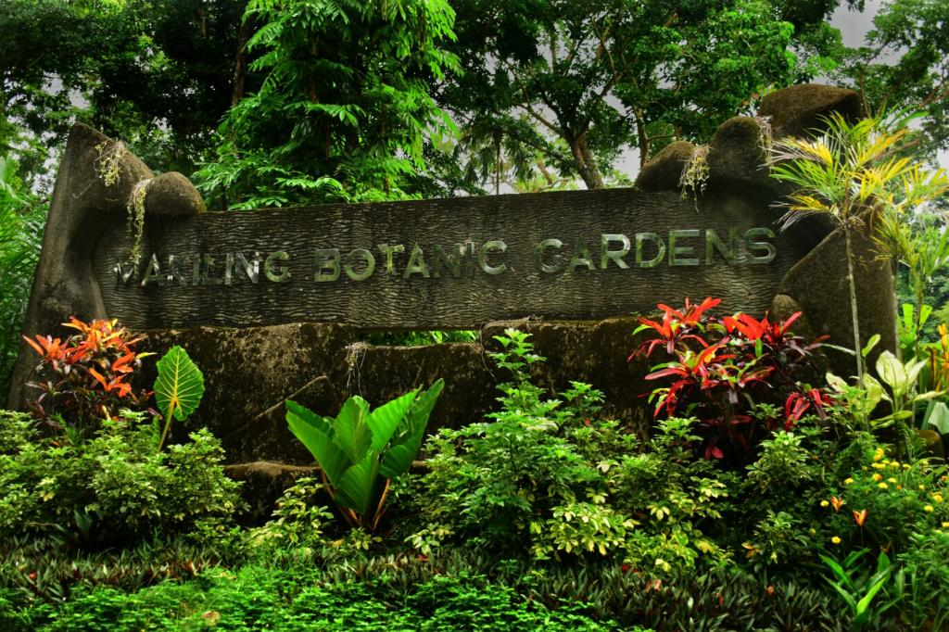

Figure 1. Entrance signage of MBG

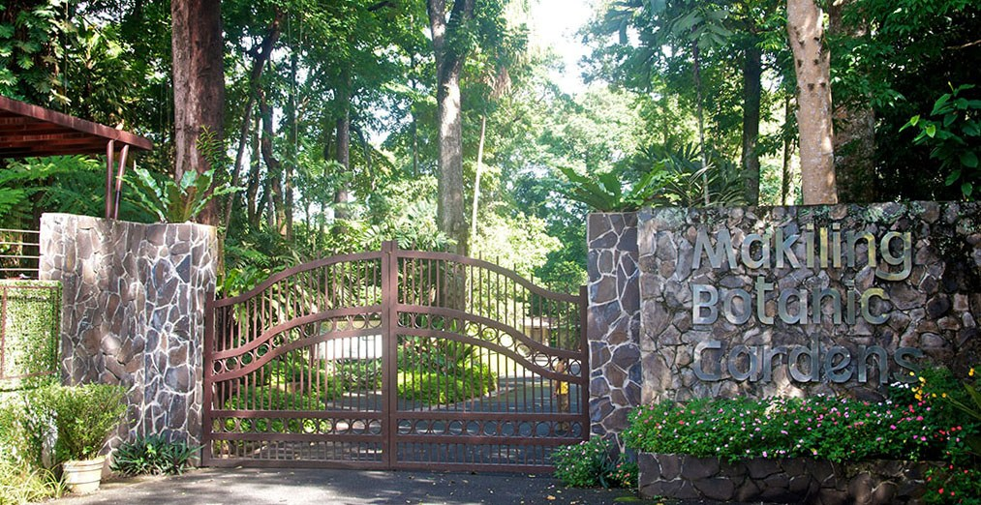

Figure 2.Gate of the MBG

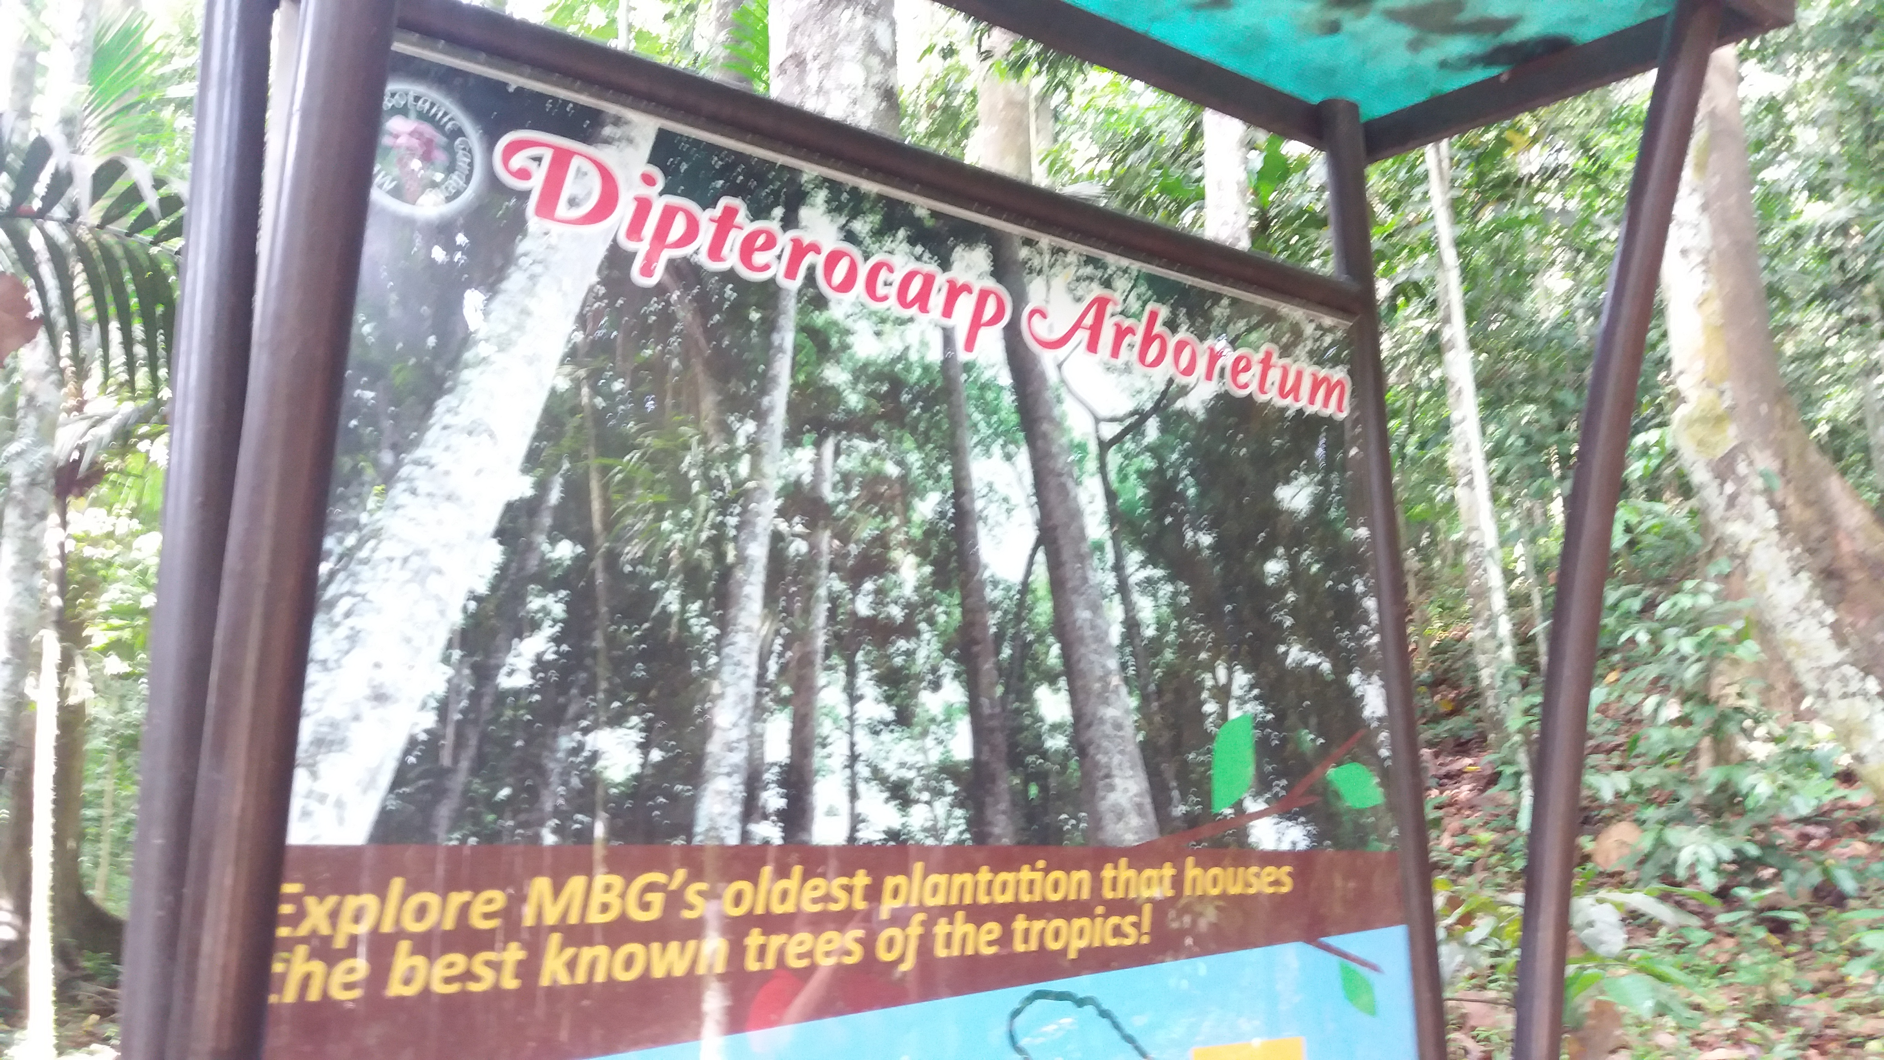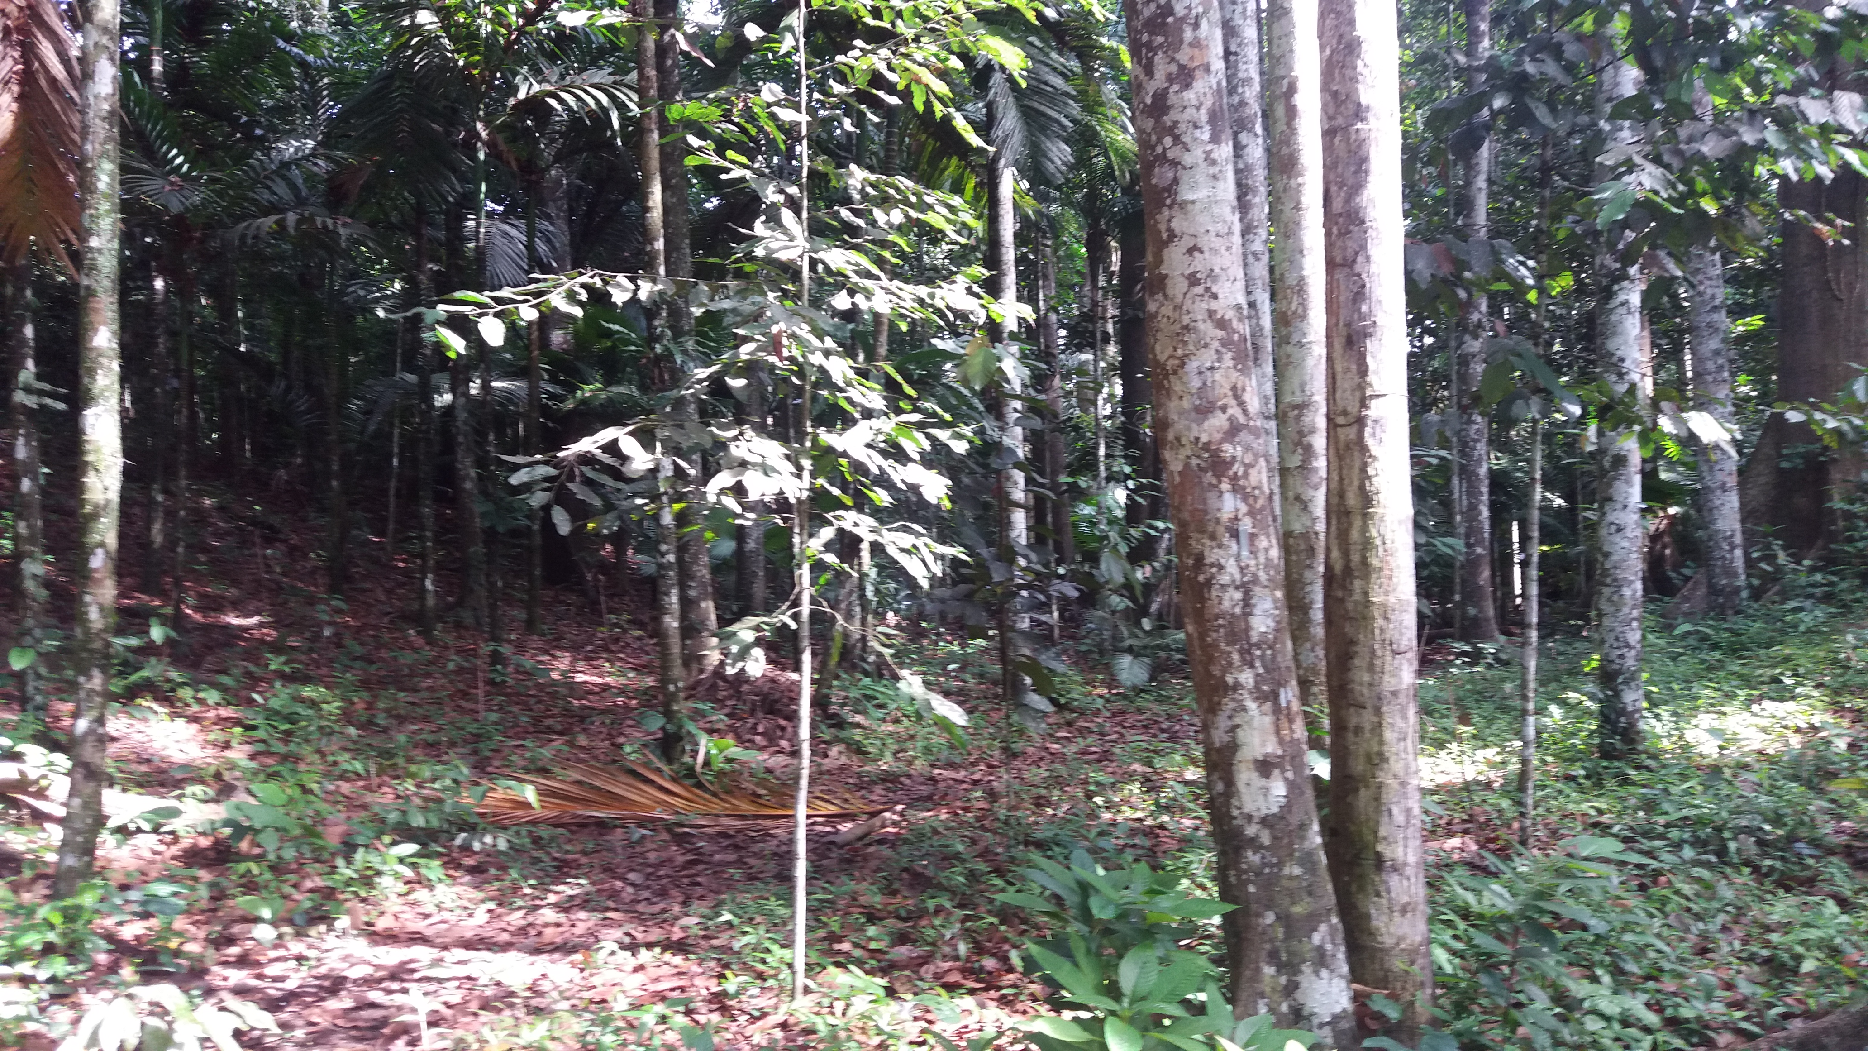

Figure 4. Dipterocarp Arboretum

**Appendix B –Final Survey Questionnaire**

Good day!

I am Krizelle Kaye M. Manese, a senior student currently taking up BS Forestry specializing in Forestry Economics. You have been chosen as one of the respondents for my study entitled “Nature-based Recreation Preferences at Makiling Botanic Gardens among Undergraduate UPLB Students.” The survey will take about 20 minutes. Are you willing to participate in this survey? This will greatly help the conduct of my study. Thank you very much!

___ Yes (request respondent to sign the Consent Form)

___ No (thank the respondent)

Questionnaire number: ___

1. **Respondent Characteristics**

Name: Age: Course: Sex:

Year Level: Freshman Sophomore Junior Senior

Xxx

What NASC courses have you taken/plan to take (Please check, all that apply)?

NASC 1- The Material Universe

NASC 2- The Living Planet

NASC 3- Physics in Everyday Life

NASC 4- The World of Life

NASC 5- Environmental Biology

NASC 6- Food and Nutrition for Healthy Life

NASC 7- Animals in Human Society

NASC 8- Practical Botany

NASC 9- Living with Microbes

NASC 10 – Forests as a Source of Life

Allowance per week: __________

Annual Gross Income of the family:

Over P 1, 300, 000

P 650,000- P 1, 300, 000

P 325,001- P 650,000

P 135,001- P 325,001

P80, 001 - P 135,001

P80, 001 and below

1. **Knowledge and Perception about Recreation and Outdoor Recreation**

According to Mc Call (1997), recreation may be considered as an activity of a person during his free time that withdraws a pleasurable and satisfying feeling. Outdoor recreation is considered as a form of resource use done in natural setting and sustainable management of resources is important to ensure the maintenance of a high quality environment and satisfaction to individual.

1. Which of these activities do you engage in (Please check all that apply)?

Jogging

Swimming

Sports activity

Hiking

Camping

Cycling

Zip lining

Picnic

Walking

watching movie/TV show

Playing video games

Surfing the internet

Reading

Writing

Others (please specify): _____________

1. Are you familiar with nature-based recreation?

Yes, proceed to question no.3 No, proceed to question no. 6

1. What do you know about nature-based recreation (Please check all that apply)?

Activities that focus on elements of natural environment

Activities that affect the behavior, perception and attitude of a person

Activities that can be done in natural settings that provide a feeling of satisfaction

Others, please specify: ___________

1. Do you engage in nature-based recreation activities?

Yes No, proceed to question no. 6

1. How frequently do you engage in these activities?

Once a week At least two times a week Once a month At least twice a month

1. What kinds of nature-based recreation activities do you wish to engage in (Please check all that apply)?

Swimming Hiking Bungee jumping Watersports Picnic Camping Others, Please specify: ________

1. Which of these nature-based recreation areas have you visited (Please check all that apply)?

Parks Beach Mountain Forests Camp sites Zoo Others (Please specify): __________

1. **Familiarity on Makiling Botanic Gardens (MBG)**
2. Are you familiar with the Makiling Botanic Gardens (MBG)?

Yes, proceed to question no. 2 No, proceed to question no. 5

1. Where did you gain information about MBG (Please check all that apply)?

Subjects (example: NASC 10) Please specify: ___________

Local Los Baños residents

Friends and Family

Fieldtrips

Social Media

Others, please specify: ________

1. Have you visited MBG?

Yes No, proceed to question no. 5

1. Among these activities that may be undertaken inside MBG, which have you engaged in (Please check all that apply)?

Bird watching Trekking Picnic Jogging Garden tour

Others, please specify: _______

1. What other activities do you want to experience inside MBG (Please check all that apply)?

Stargazing Obstacle Course Day Camping Overnight Camping

Exposure to endemic plants Zip line Others, please specify: _________

1. **CV scenario**

The Makiling Botanic Gardens (MBG) is a botanic garden inside the Mt. Makiling Forest Reserve, which provides a place for research and recreational activities. At present, however, the recreational activities available to visitors are limited only to day activities. As a result, the full potential of MBG in providing recreation services is not realized, and affects MBG’s visitation rate and income-generating capacity.

Suppose overnight camping will be allowed at MBG. Overnight camping can give several benefits to people. It can lessen stress and people can enhance personal characteristics from the experience like leadership, character development, self-esteem, decision-making skills, independent living skills, and citizenship.

However, visitors who will avail the overnight camping service will need to pay an additional charge on top of the current entrance fee of P20/visitor. The overnight camping fee will provide visitors access to MBG’s camping facilities, such as areas for tents, cooking, bonfire, and team-building activities. The fee will be used by MBG to maintain and improve the overnight camping facilities. Visitors will need to bring their own camping gear, e.g. tents, and will need to follow the overnight camping regulations of MBG to ensure visitors’ safety and the integrity of MBG as a botanic garden.

(Show pictures of the proposed campsite and other areas where activities may be undertaken).

1. Will you be interested in overnight camping at MBG?

Yes, proceed to question #2 No, proceed to question #3

1. If yes, what features of overnight camping do you prefer (Please check all that apply)?

Bonfire

Tents for rent

Obstacle course

Hunting courses

Team building activities

Picnic areas

Cooking areas

Others, please specify: ________________

1. If no, what will hinder you from participating in the overnight camping?

I am not an outdoor person

I am afraid of wildlife

I do not prefer extreme activities

I prefer activities other than overnight camping

Others, please specify: __________________

1. Are you willing to pay an additional fee for overnight camping on top of the current entrance fee of ___/visitor??

Yes, proceed to question #5 No, proceed to question #6

1. Are you willing to pay ____P/night for overnight camping at MBG?

Yes No

1. What are the reasons why you are not willing to pay?

The price is too high.

I think the facilities are not worth the price.

I cannot afford additional increase in entrance fee.

[Kye‐Sung Chon](http://www.emeraldinsight.com/author/Chon%2C+Kye-Sung), (1989)z

I do not care in the maintenance of the garden

Others, please specify: _______________

Thank you for agreeing to participate in this study!

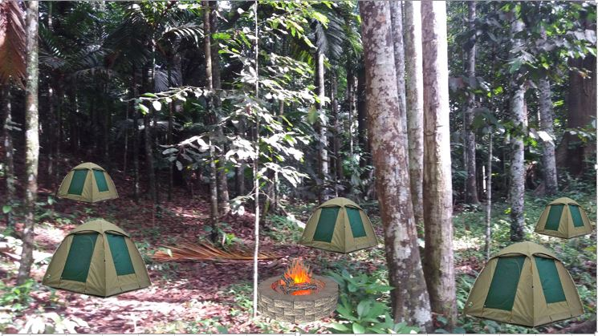

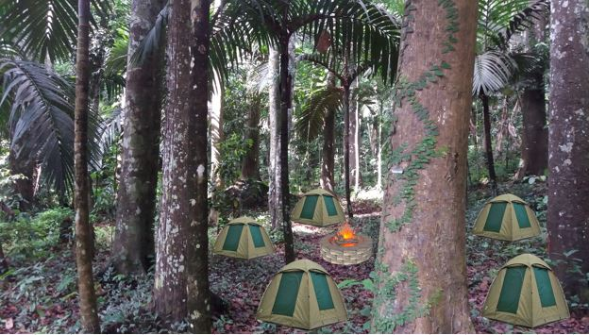

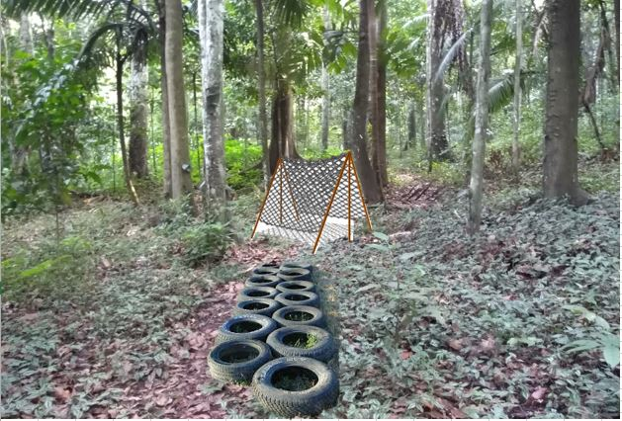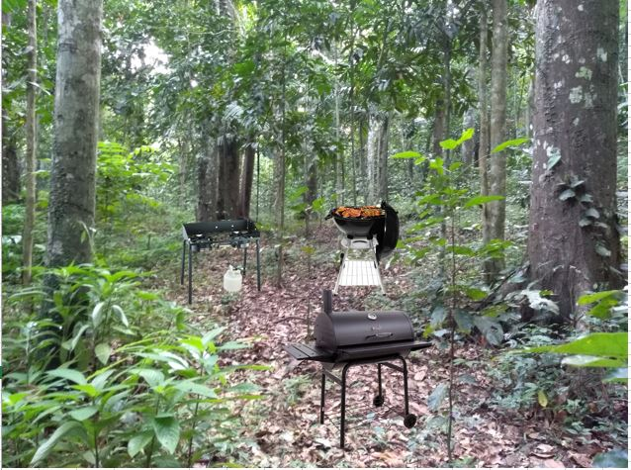

**Appendix C- The Consent Form**

**Consent Form for Participation in a Research Study**

**Recreation Preferences of Undergraduates UPLB Students at the Makiling Botanic Gardens**

**Description of the research and your participation**

You are invited to participate in a research study conducted by Krizelle Kaye M. Manese. The main purpose of this research is to evaluate the potential overnight camping at MBG. It specifically aims to describe the recreational activities of UPLB undergraduate students, to describe other recreation activities at MBG that college students are interested in, to assess the interest of college students in overnight camping at MBG and to estimate their willingness to pay for overnight camping.

Your participation will involve answering a survey questionnaire about your recreation activities. It will also be about your interest in participating in potential overnight camping at Makiling Botanic Gardens (MBG). I will also be asking about your willingness to pay if additional fee will be implemented.

**Risks and discomforts**

There are no known risks associated with this research.

**Potential benefits**

This research may help me to understand the recreational activities preferences of UPLB undergraduate students. This will also help the Makiling Botanic Gardens (MBG) to improve the activities in the garden.

**Protection of confidentiality**

The records of this study will be kept strictly confidential. I will do everything I can to protect your privacy. And lastly, your identity will be disclosed in the material that is published.

**Voluntary participation**

Your participation in this research study is voluntary. You may choose not to participate and you may withdraw your consent to participate at any time. You will not be penalized in any way should you decide not to participate or to withdraw from this study.

**Contact information**

If you have any questions or concerns about this study or if any problems arise, please contact Dr. Margaret M. Calderon at Institute of Renewable and Natural Resources, CFNR, UPLB. If you have any questions or concerns about your rights as a research participant, please contact the University of the Philippines Los Banos.

**Consent**

**I have read this consent form and have been given the opportunity to ask questions. I give my consent to participate in this study.**

Participant’s signature_______________________________ Date:_________________

**Appendix D**

Table 1. Coding guide in STATA

|  |  |  |
| --- | --- | --- |
| **Variable** | **Description** | **Code/Value** |
| RN | Respondent's number | 100 |
| age | Age of the respondents | Age, number |
| Allowance | Allowance of the respondents | Amount, number |
| Sex | Sex of the respondents | 1= Female  0= Male |
| College | College of the Respondents |  |
| college that is highly related on environment | CAFS=1  CFNR=1  CHE=1 |
| college that is not highly related on environment | CAS=0  CDC=0  CEAT=0  CEM=0 |
| CDC=0  CEAT=0  CEM=0  CVM=0 |
| NASC taken | Environmental NASC | NASC 5= 1  NASC 8=1  NASC 10=1 |
| Not related on environment NASC | NASC 1=0  NASC 2=0  NASC 3=0  NASC 4=0  NASC 6=0  NASC 7=0  NASC 9=0 |
| VisitedMBG | visitation on MBG | 1= Yes  0=No |